Worksheet 3.5

Ages of fossils
Answers

Relative ages
1. The following cliff face diagram contains numerous rock layers and fossils.
A
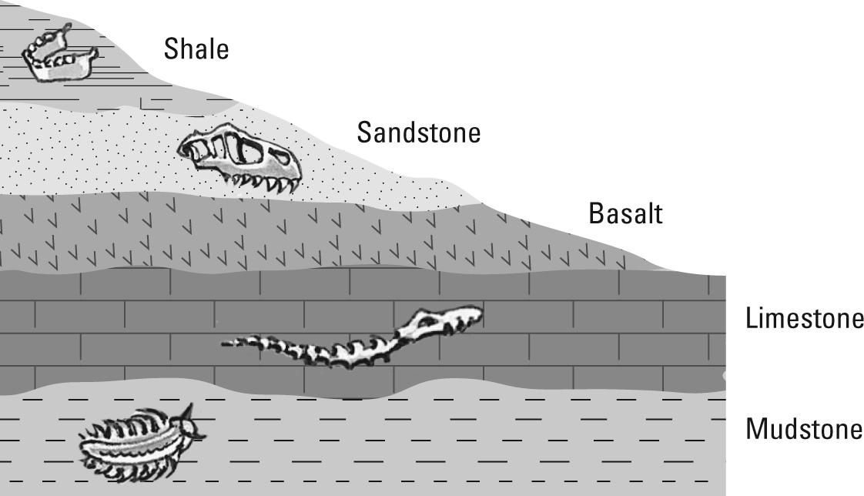
B
D
C

(a) Identify the youngest and oldest sedimentary rock layer in this sequence.
Youngest = shale; oldest = mudstone

(b) Using the code letters (A–D), arrange the fossils in order from oldest to youngest.
D, C, B, A

(c) Explain why there are no fossils in the basalt rock layer.
Basalt is an igneous rock that was once molten. Fossils are usually destroyed by molten rock.

Worksheet 3.5

Page 2

Radiometric C-14 dating
2. The absolute ages of recent carbonaceous fossils can be determined using radiocarbon dating.
The half-life of carbon-14 (a radioactive isotope) is 5730 years. The following table shows how the percentage of C-14 present in a fossil decreases over time.
Time (years) | 0 | 5730 | 11 460 | 17 190 | 22 920 | 28 650
% C-14 remaining | 100 | 50 | 25 | 12.5 | 6.25 | 3.125
(a) Complete the table.
(b) Plot a line graph of this data on the grid below.
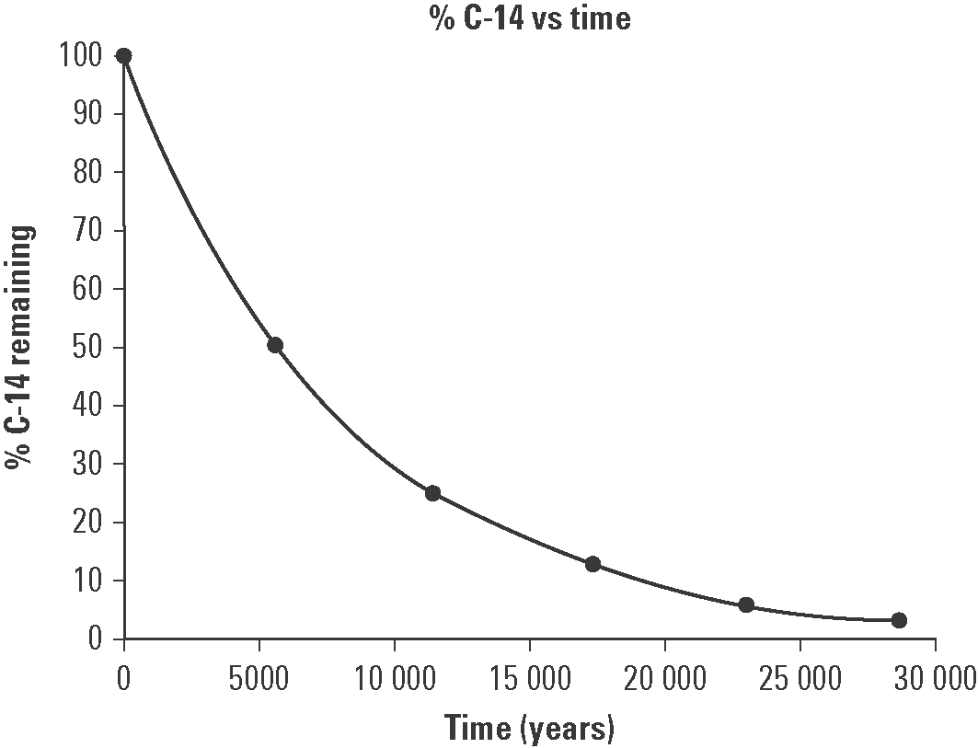
(c) The C-14 content of a fossil was found to have decreased by 36% since the organism died. Determine the approximate age of the fossil.
64% carbon-14 remains
From graph: Age = 4000 years

(d) A fossil is approximately 10 000 years old. What percentage of C-14 still remains?
30% C-14 remains (from graph)

(e) Explain why it is difficult to date fossils that are more than 60 000 years old using radiocarbon dating.
After 60 000 years very little C-14 remains to measure.

